How to Install JDK???

1. Click on the Core Java that is present in the cd

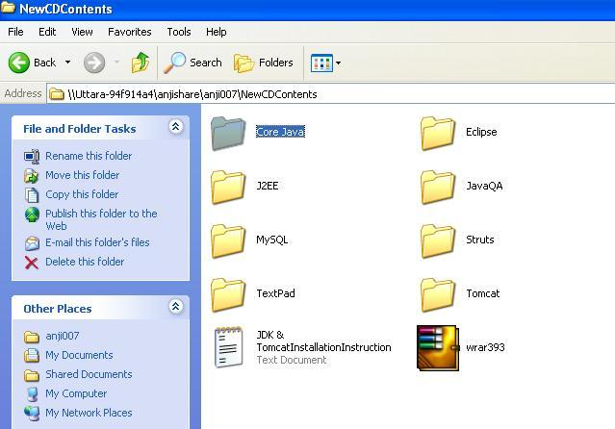

2. Double Click on SDK

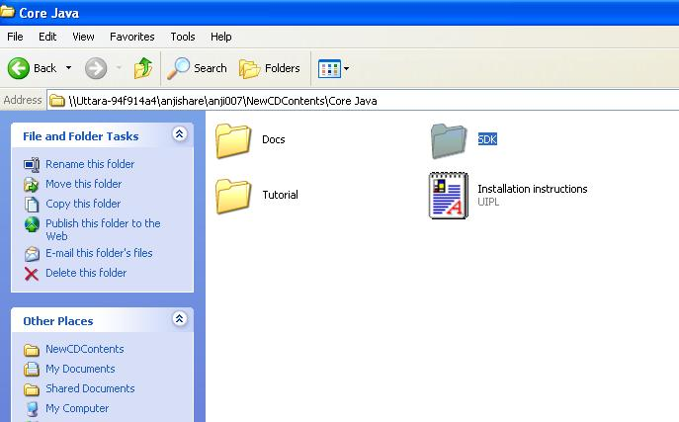

3. Double Click on jdk-1_5_0_03

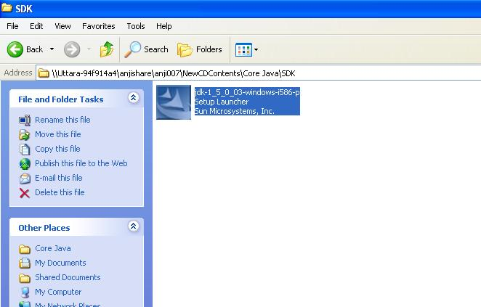

4. Click on I accept the terms and then Next

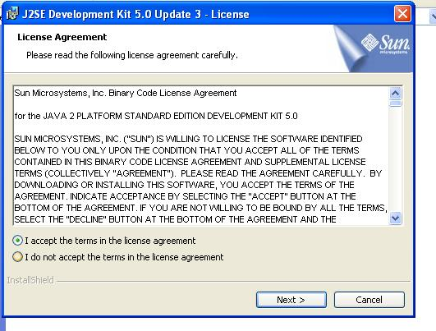
5. Next

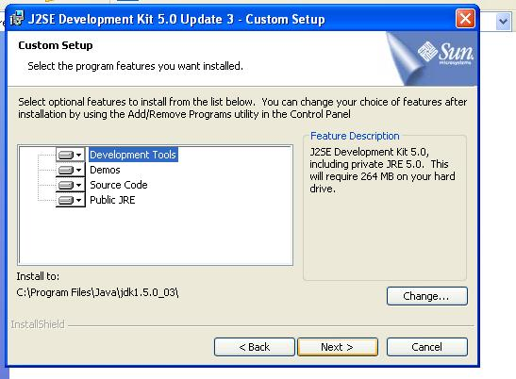

6. It starts Installing

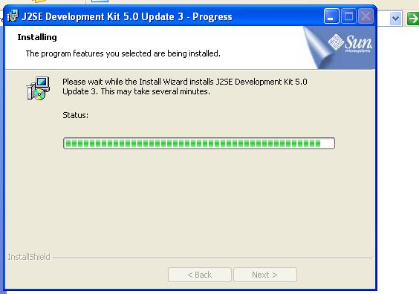

7.Click on Next

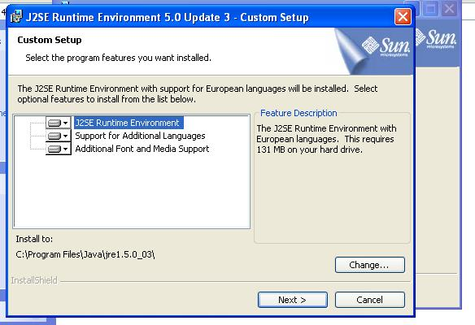

8. Select the browser and click on Next

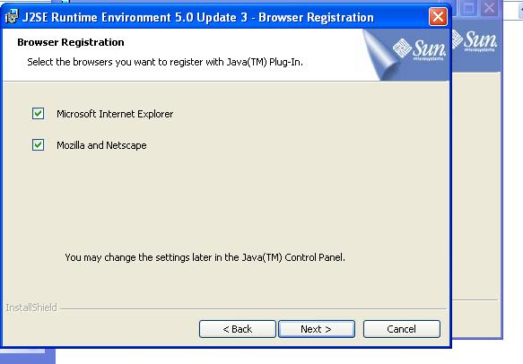
9. Runtime Environment is installing

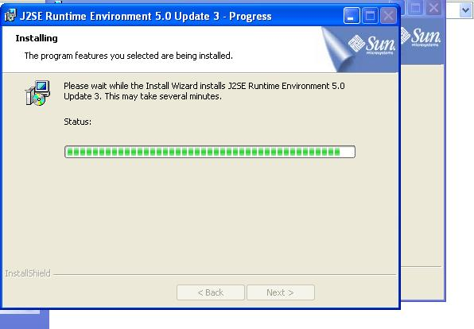

10. Click on Finish

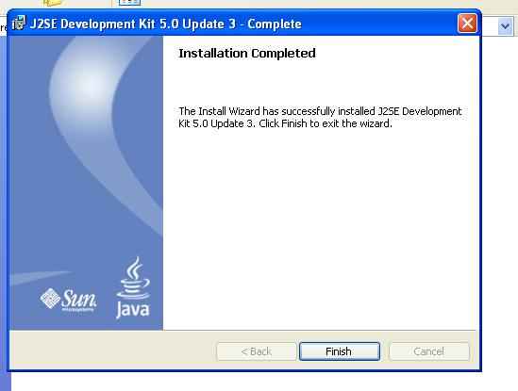

11. Go to Control Panel and Click on System

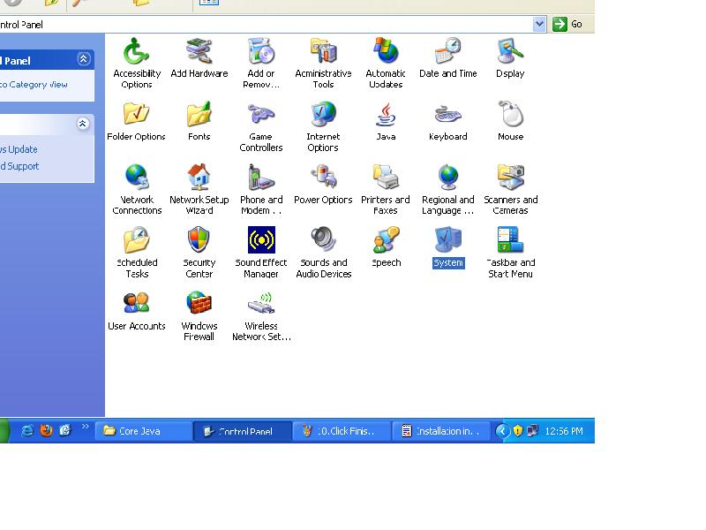
12. Click on Advance Variables and Then Environment Variables

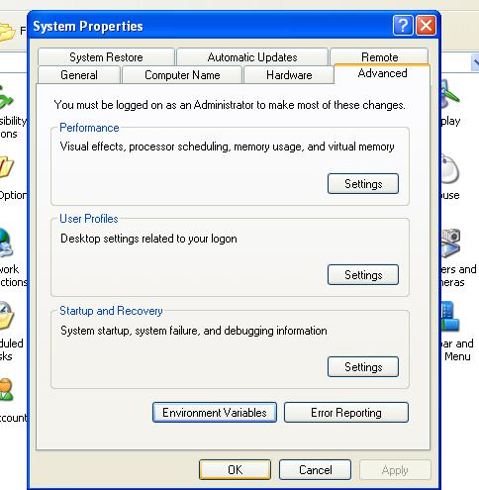

13. Go to C -> Program Files -> Java -> jdk1.5.0_03

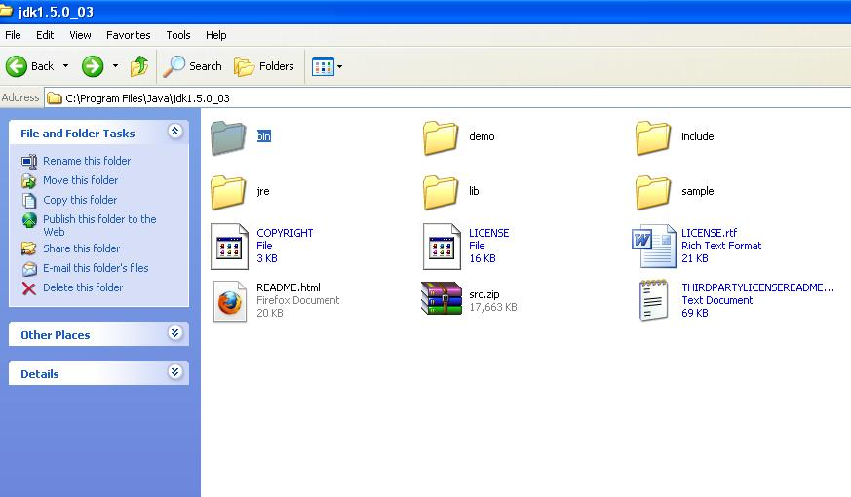

14. And then to bin and copy the path

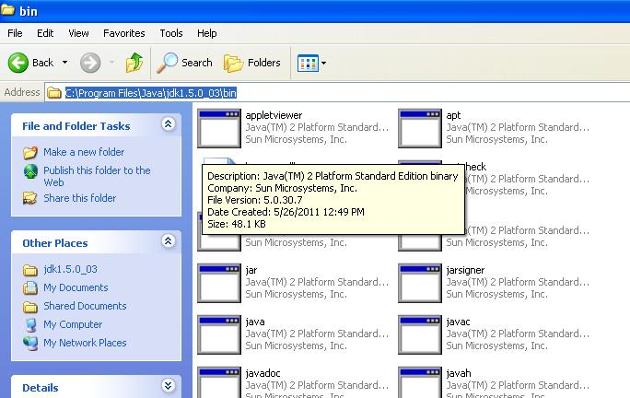

15. In Environment Variables, go to System Variable’s Path and Click on Edit

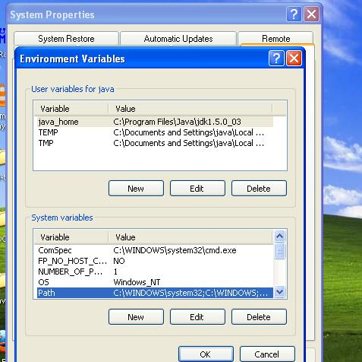

16. Variable name is Path and for Variable Value paste the path copied i.e C:\Program Files\Java\jdk1.5.0_03\bin and click on ok.

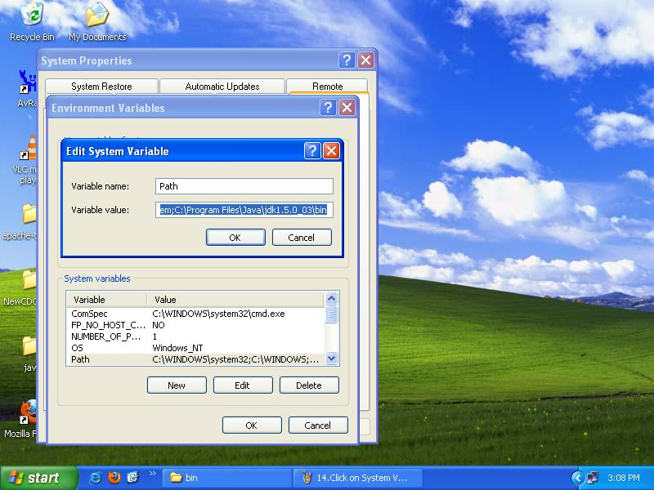

17. Then Click on User Variable’s New and Give Variable name java_home and for Variable Value copy the same path but excluding bin i.e C:\Program Files\Java\jdk1.5.0_03 and click ok for all

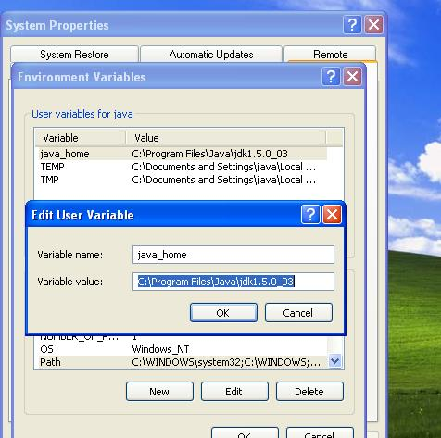

18. To check whether the jdk is installed properly or not, go to Command Prompt and give javac, if you can the list of options, then its installed correctly.

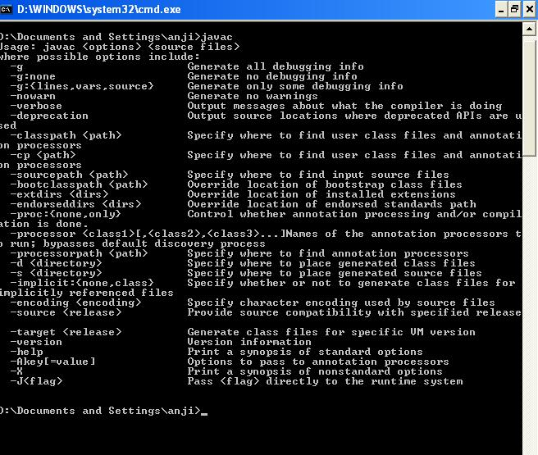
19. Go to C and create a folder

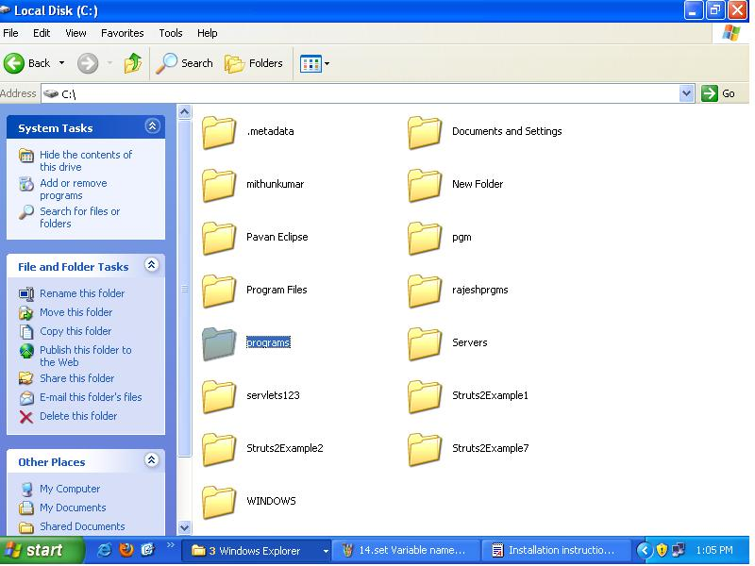

20. In that folder, create two new folders of name Classes and Source. Source is for the source code where you save the program and Classes is for the java class

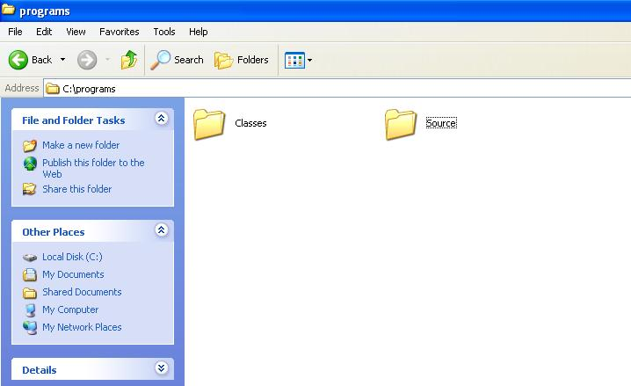
21. Go to TextPad and write the program

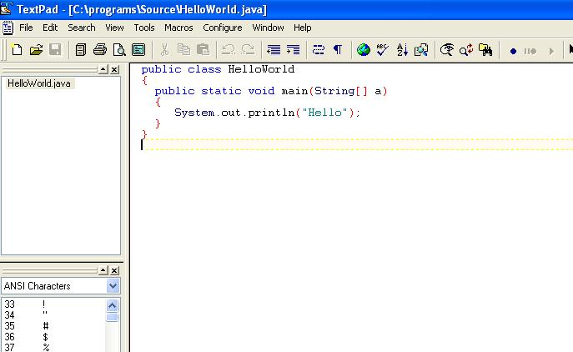

22. And save the program in C - > folder you created - > Source in Java format

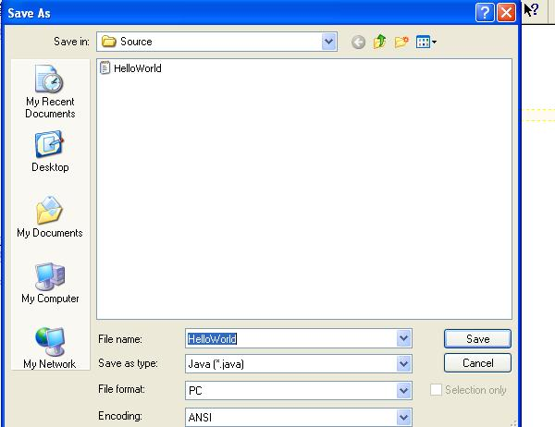

23. To compile, go to Command Prompt, and change the folder to where the file is stored i.e C:\Folder you created\source

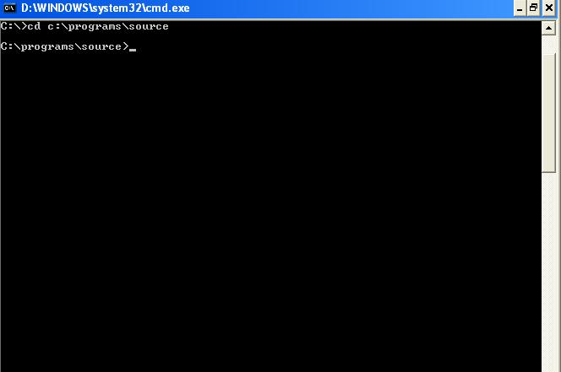

24. After changing the folder, to compile give the command javac –d ../classes ProgramName.java. The class file will get stored in Classes folder.

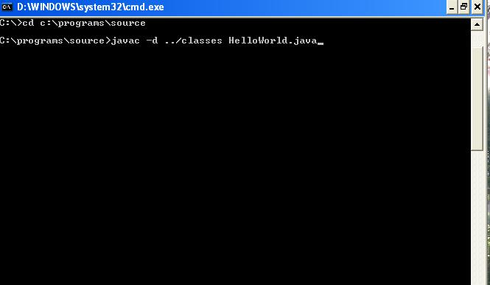

25. After success completion of compiling, change the folder to classes. First come out of source using cd.. command and then change to classes

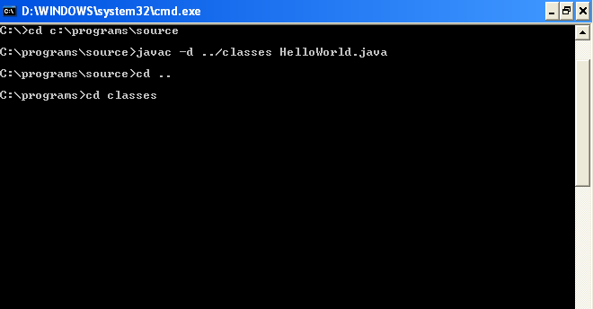

26. To run the program, give java –cp . ProgramName and enter

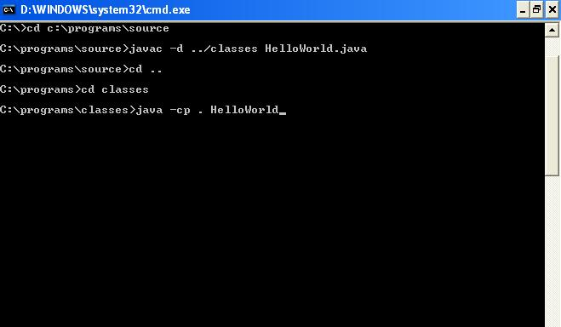

27. And the output is seen
